Declaration of Interest
For cooperation within ICLD’s Municipal Partnership Programme
Send to partnership@icld.se

The objective of the Municipal Partnership Programme is to reduce poverty by promoting
functioning, democratic local and regional politically controlled bodies, within which residents
can influence political processes. In mutual partnerships, both partners exchange knowledge and experience to improve their institutional capacity within four thematic areas: Equity, Participation, Transparency and Accountability. Participation requires time and commitment from both partners, the funding from ICLD finances the exchange of knowledge and experiences between the partners, there are no funds for investments available through the programme. Read more on www.icld.se

Date:
Local government (municipality/region/county):  JINJA CITY | Contact person:  KUBWOOYO ROGERS
Address:  Plot 7 A, Busoga Square, Bell Avenue East, P.O.BOX, 720, JINJA. | E-mail:  rkubwooyo@yahoo.com
Postal code:  +256 | Phone:+256 772 563 596, +256 701 442 222
City and country:  JINJA – Uganda. | Municipality Website and/or social media accounts (if applicable):

A.
Jinja City’s prioritised list of the top three areas of function include:

1. Local economic development (industrial and commercial development, tourism, rural development);

2. Sustainable urban development;

3. Cultural and leisure activities;

Other areas: Technical municipal services (e.g. waste management, water and sewage, energy);

-Jinja City is implementing local economic development under a parish model arrangement in line with the country’s NDPIII and the SDGs, intended to increase people’s incomes through appropriate industrial value additional technologies in an inclusive, participatory and transperent manners that would reduce poverty and enhance peoples quality of life.
-It is also implementing urban sustainable development through inclusive physical planning, usage of renewable energy, sustainable mobility by establishing streets for only pedestrians and cyclelists.
-It is also working with cultural istitutions to preserve the historical heritage sites and cultures that have become key in enhancing tourism. Jinja City is a major tourism area with leisure activities like, visiting, source of the river nile, white water rafting downstream, it is also the home of the famous Nyengenyege festival at discovery resort which attracts revelers allover the world for leisure.

Howerver, all these efforts have not adequately involved the community for, the technical persons who are at operational levels like the parish chiefs, lack knowledge, skills and exposure to such programs for their successful implementation even when such programs are geared towards democracy, Equity/inclusion, participation , transpernce and, accountability.

B. Short description of Jinja City local government: (Vision, mission, main parties in political leadership and opposition, name of mayor, size of organisation etc)

Jinja City, is located along the source of the River Nile and on the shores of Lake Victoria in Eastern Uganda. It is the second largest town and second busiest center in Uganda with a land size measuring 215 square kilometers including parts of the waters of Lake Victoria and river Nile. It is has night resident population of 350,000 people. Jinja started as fishing village in 1907. It is dubbed the Adventure capital of East Africa due to the various adrenaline adventure sport activities that are attracting tourist to this place.

Vision of jinja city is, to attain a prosperous urban community with Excellence in Tourism, Commerce and Industry.

Mission: To improve the quality of life of all residents through tourism promotion, commerce and, revitalized industrial economy with equitable access and enhanced, attractive and sustainable environment.

Objectives:
- To promote, local Economic development
- To reduce poverty and improve livelihood status of the community
- To promote Tourism and cultural development
- To improve access to and quality of health services and reduce prevalence diseases
- To foster Education and, human capital development
- To improve governance and management

The City is headed by the City Mayor Mr. Kasolo Alton from the leading opposition political party of National Unit Platform (NUP) that has majority of councilors within the council. However, the council is constituted with members from a number of political parties that include; National Unit Platform (NUP), Forum for democratic Change (FDC) and from the ruling party of National Resistence Movement (NRM).
The council management is constituted of 24 councillors inclusive of the mayor and, eleven(11) heads of department including, the City Clerk who is the technical admistrative head in the names of Daniel Kawesi

C. Type of Region and Main Sources of Income:
The biggest part (60%) of Jinja City is of a rural setting with the main sources of income being, Tax and Non-Tax revenues like, property tax, ground rent, Trading licence, Hotel Tax, Local Service taxi, Market dues and get collections from both local and international tourists at Source of the river nile. The City receives both conditional and non conditional grants from the Central government that forms the biggest source of funding

D. Population size and demographic composition:

Jinja City population oscilates between 500,000 peple during the day and, a night population of 350,000 people. 60% of the total population are women and, 70% of that tatal population, are young people bellow the age of 35 years.
E. National cooperation.

Jinja city is a member of Uanda urban local authorities association, a body that brings urban local governments together. It is also a member of LVLAC ( lake Victoria local authorieties cooperation) a boby that brings local government authoristies that share the lake Victoria within East Africa.
Jinja City is also implementing an urban migrant project with Makerere University.
The City also collabourates with a number of Non government organisations in the areas of Local Economic Developent, management of street children among others.

F. International cooperation.
Jinja City, while still a municipality, had a partnership with the City of Skellefteå in northern Sweden with exchange pragrammes in areas: City planning with the participation of the children, city beautification and management of green spaces among others.

Jinja City is implementing, Jinja –Iclei –TUMI project of sustainable mobility.

-Jinja –UN habitat project that involved in capacity building of community housing development, city development strategic planning which culminated into elevation of Jinja to City status.
Jinja City is now implementing the National Development plan III in line with United Nations sustainable development goals under a parish development model intended to spur, Local Economic Development

G. Pictures of motives
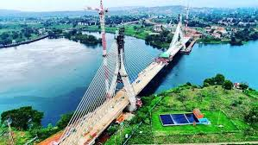
The New Nile Bridge to facilitate transport and Tourism

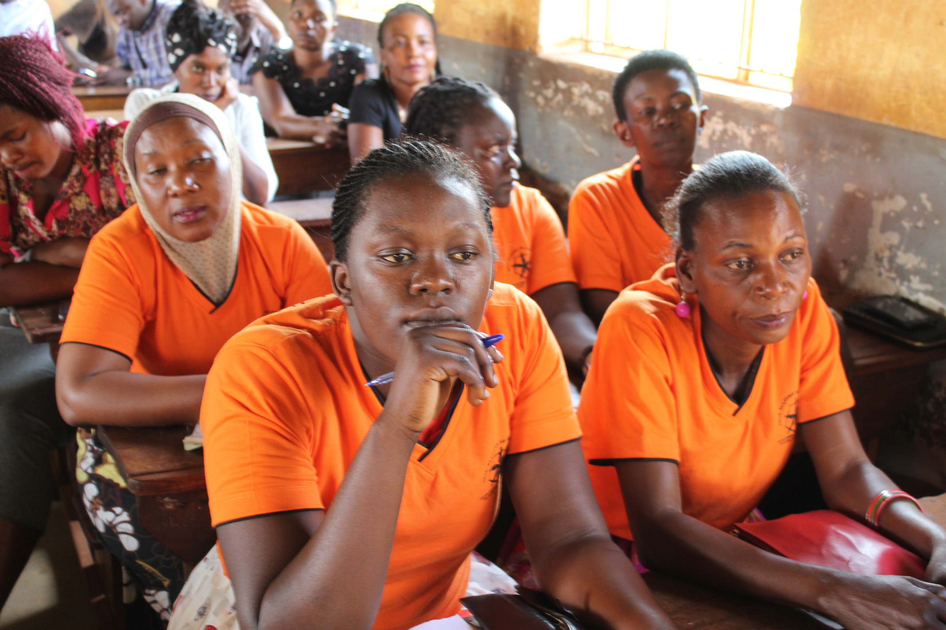

Community traing on Gender and Local Economic Development

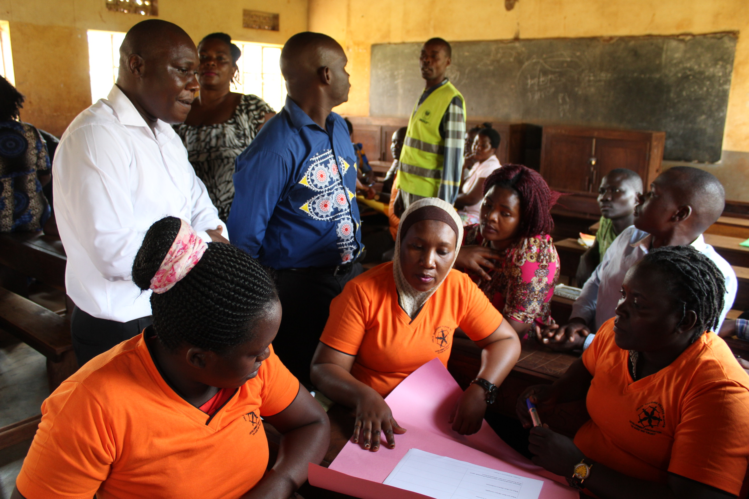
Community traing on Gender empowerment and Local Economic Development with the City Commercial Officer in a white shirt

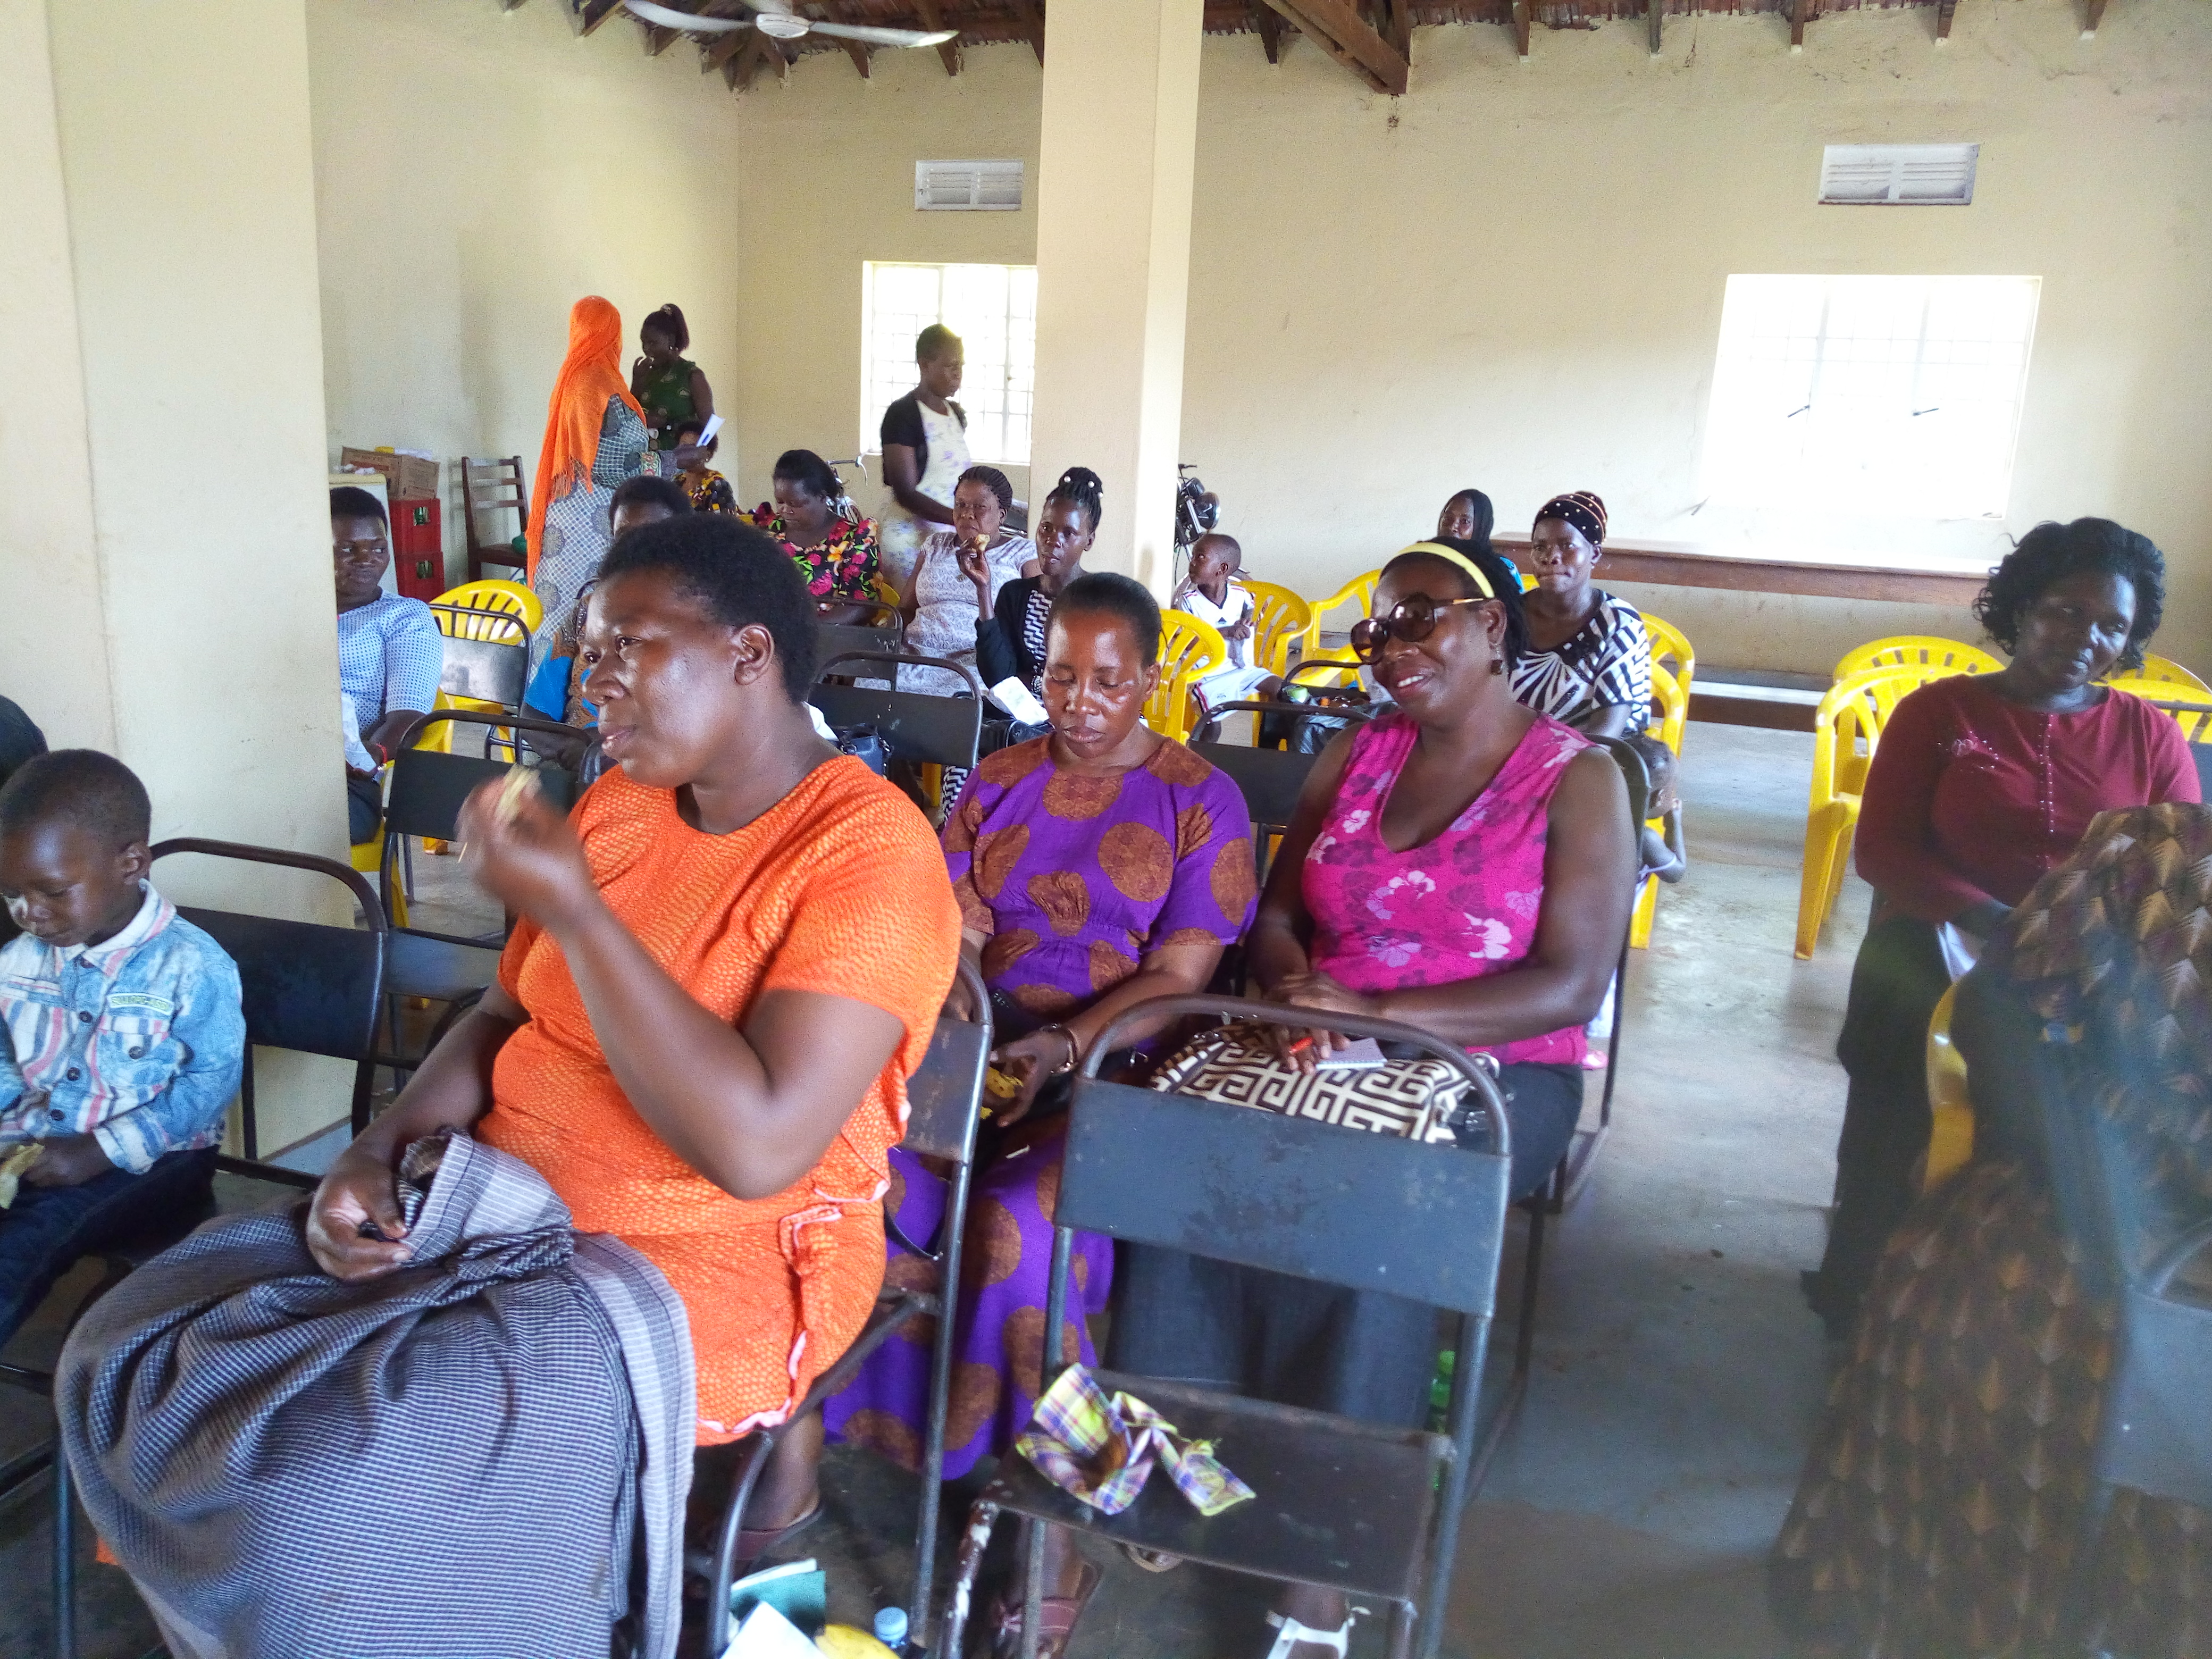

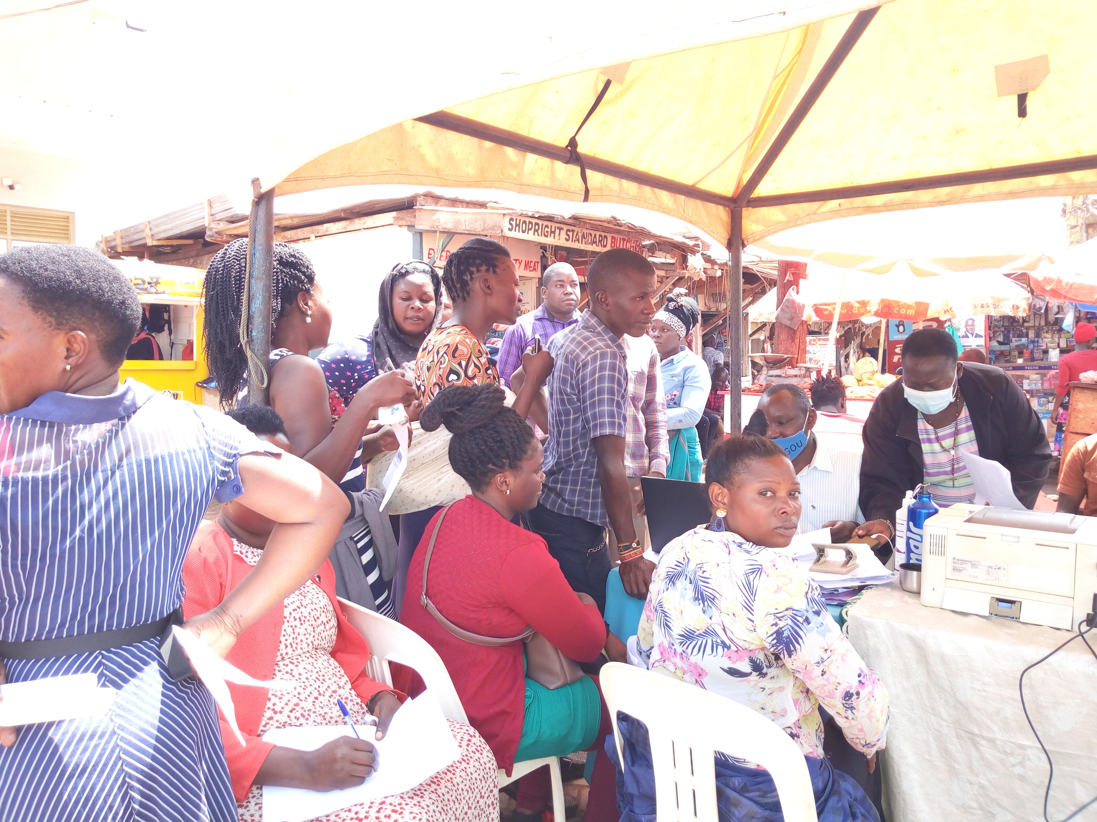
Jinja City’s business development services clinic as part of local economic development initiative

